SAPO 5 –  Proof of Service |  |  |  | 
 |  | Have the server complete this form after serving papers on «Other party name first TE»

Form SA-4.020: Return of Service
Quick Instructions:
 | 1. |  | Review the forms  Make changes if needed
 | 2. |  | Have the server fill out details. Date and sign the form  Be sure they complete section 2 or 3:  - Date, time, and address of service, or  - Attempts to serve  And list all documents served in section 4
 | 3. |  | Make one copy  For yourself
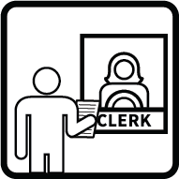 | 4. |  | File the original with the court clerk  Stamp your copy with the date filed

«INSERT "Inserted template SA 4-020 - Return of Service.rtf" KEEP HEADER FOOTER»

